**A Photographic Essay on Youth Empowerment Through Education in African Communities**

**Introduction: The Power of Knowledge**

Education is the cornerstone of development and empowerment, yet many young people in African communities face significant barriers to accessing quality education. This photographic essay explores the transformative power of education and its role in shaping the future of Africa’s youth.

**The Hopeful Classroom**

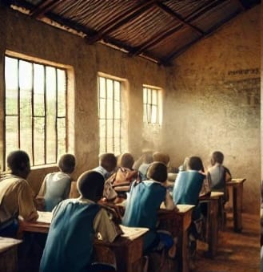

A small classroom filled with eager students, some seated on makeshift benches while others stand, attentively listening to their teacher. The classroom is modest, but the determination in the students' eyes reflects their hunger for knowledge.

*Despite limited resources, the thirst for education drives these students to strive for a better future.*

**The Struggle to Learn**

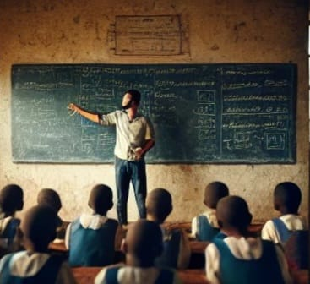

A young boy reads a textbook under a dim light in his home. The walls are simple, and the light is faint, but his focus is unwavering. This image highlights the challenges many students face, from inadequate lighting to lack of educational materials, yet they persist.

*Overcoming obstacles—dedication to learning in the face of challenges.*

**The Empowered Girl**



A teenage girl stands proudly in her school uniform, holding her books close. She smiles confidently, aware that her education is a powerful tool for changing her life and her community. This image emphasizes the importance of empowering girls through education.

*Educating girls is key to transforming communities and breaking the cycle of poverty.*

**Learning Beyond the Classroom**

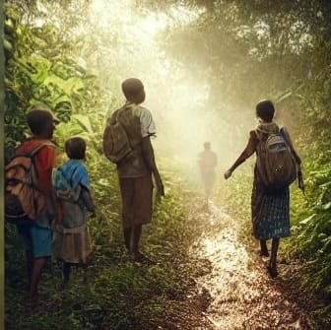

Students gather around a teacher outdoors, learning practical skills such as agriculture, oratory, or craftwork. This image shows that education is not confined to the classroom; it extends to life skills that are essential for survival and growth.

*Practical education prepares youth for real-world challenges, equipping them with essential life skills.*

**The Challenge of Distance**



A group of children walks miles along a dusty road, making their way to school. Some carry their shoes to avoid wearing them out, others have none. The journey is long and arduous, yet they are driven by the promise of education.

*The long road to education—determination fuels these students' daily trek to school.*

**The Role of Technology**

A small group of students huddles around a shared computer in a rural classroom. The excitement is evident as they explore the digital world, learning new skills that connect them to opportunities beyond their immediate environment.

*Technology in education opens doors to global knowledge, bridging the gap for rural students.*

**The Future Leaders**



A graduation ceremony in progress—students in caps and gowns, surrounded by proud family members. This image celebrates the culmination of years of hard work and the beginning of a new chapter, symbolizing the hope that education brings for a brighter future.

*Graduation marks the transition from student to leader, paving the way for future success.*

**Conclusion: Building Tomorrow’s Leaders Today**

Education is more than just a pathway to employment; it is a tool for empowerment, a means to break the cycle of poverty, and a foundation for building strong, resilient communities. This photographic essay underscores the importance of investing in education to create opportunities for African youth, ensuring that they have the tools they need to lead and innovate in the future.